
All in the Family –
Genetics and Family Health History

GeneFrom Slime to Sublime

Video Description
“Secrets of the Sequence,” Show 08-1
“All in the Family – Genetics and Family Health History” – approximately 9 minutes viewing time
www.pubinfo.vcu.edu/secretsofthesequence

A family with an inherited health condition gathers its medical history to empower its youngest generation. At Virginia Commonwealth University’s medical center, Kristin Stevens is bringing five-year old Patty and three-year old Amanda for a check up with clinical geneticist Dr Joann Bodurtha. This segment looks at the heredity health history of a family.

Producer/Director: Liz Boggis
Executive Producers: Dick Rezba and Cynthia Schmidt
Editor: Melissa Gordon; Narrator: Alan Sader; Camera: Dave Park; and Sound: Jeff McGall
Featuring: Dr. Joann Bodurtha, Human and Molecular Genetics, Virginia Commonwealth University and the Stevens family – Kristin, Joe, Patty and Amanda
Lesson Author: Melissa Csikari
Reviewers: Sandra Marr and Sandra Joy Casad
Trial Testing Teachers: Emily Betts and Robin Gurczynski

This video and 50 others with accompanying lessons are available at no charge from www.vcu.edu/lifesci/sosq

National and State Science Standards of Learning
National Science Education Standards Connection

Life Science
As a result of activities in grades 9-12, all students should develop an understanding of:
- Molecular basis of inheritance.
Personal and Social Perspectives
As a result of activities in grades 9-12, all students should develop an understanding of:
- Personal and community health.
History and Nature of Science
As a result of activities in grades 9-12, all students should develop an understanding of:
- science as a human endeavor and
- The nature of scientific knowledge.

Selected State Science Standards Connection
Use http://www.education-world.com/standards/state/index.shtml (click on the pull-down menu to select a state) or use a search engine to access additional state science standards.

Virginia Standards
Bio. 6 The student will investigate and understand common mechanisms of inheritance and protein synthesis. Key concepts include
d) Prediction of inheritance of traits based on the Mendelian laws of heredity.
e) Genetic variation (mutation, recombination, deletions, additions to DNA).
h) Use, limitations, and misuse of genetic information; and
i) Exploration of the impact of DNA technologies
Health 10.4 The student will synthesize and evaluate available health information, products, and services for the value and potential impact on his/her health and wellness throughout life. Key concepts/skills include
a) The use of current technological tools to analyze health products and services;
b) The impact of technology on the health status of individuals, families, communities, and the world;

North Carolina Standards
3.03 Interpret and predict patterns of inheritance.
- Dominant, recessive and intermediate traits
- Multiple alleles
- Polygenic inheritance.
- Sex-linked traits.
- Independent assortment.
- Test cross.
- Pedigrees.
- Punnett squares.
3.04 Assess the impact of advances in genomics on individuals and society.
- Human genome project
- Applications of biotechnology

4.04 Analyze and explain the interactive role of internal and external factors in health and disease:
- Genetics

Overview
We all know that certain conditions run in the family, that our genes pass inherited traits from one generation to the next. Sometimes a family knows they have a genetic health condition, but pinpointing the exact problem can involve a lot of medical detective work. One key to unlocking the mystery is the family’s own health history. In this age of molecular medicine, information about health conditions that run in your family can be a powerful diagnostic tool to help you stay healthy. A family medical history, often called family tree of health or pedigree, is a graphic record of illnesses and medical conditions affecting family members. A family tree of health should also include information about each family member’s diseases, age of disease onset, and cause of death.

In addition to genetic information that determines your appearance, you also inherit genes that may cause or increase your risk of certain medical conditions. A family medical history can help a physician interpret the history of disease in your family by: 1) observing patterns and identifying conditions and risks before they affect you, 2) preparing, planning or taking steps to avoid or minimize these conditions, 3) deciding what tests may be needed to come to a diagnosis, and 4) identifying other family members who may be at risk and calculating your chance of passing certain diseases to your children.

Testing: Sample related multiple choice items from State Standardized Exams

- Timothy has attached earlobes like his maternal grandfather. His mother and father both have free earlobes, which are dominant. Which statement best explains how Timothy inherited attached earlobes?
- He received a recessive allele from each parent. ←
- He received a dominant allele from each parent.
- He received a recessive allele from his mother and a dominant allele from his father.
- He received a dominant allele from his mother and a recessive allele from his father.

Source: Spring 2007 released test: End of course biology

- In 1910, Thomas Morgan discovered traits linked to sex chromosomes in the fruit fly. The Punnett square below shows the cross between red-eyed females and white-eyed males. Fruit flies usually have red eyes. If a female and male offspring from the cross shown below are allowed to mate, what would the offspring probably look like?

 | X^{r} | Y
X^{R} | X^{R} X^{r} | X^{R} Y
X^{R} | X^{R} X^{r} | X^{R} Y

- 2 red-eyed females; 2 white-eyed males
- 2 red-eyed females; 1 red-eyed male, 1 white-eyed male
- 1 red-eyed female and 1 white-eyed female; 2 red-eyed males
- 2 white-eyed females; 1 white-eyed male and 1 red-eyed male

Source: Spring 2001 released test: End of course biology

- In corn plants, Green (G) is dominant to albino (g). According to the Punnett square below, what is the chance of this heterozygous cross producing albino corn plants?

 | G | g
G | GG | Gg
g | Gg | gg
- Four in four
- Three in four
- Two in four
- One in four

Source: 2003 released test: End of course biology

- In snapdragons, the combined expression of both alleles for flower color produces a new phenotype that is pink. This illustrates incomplete dominance. The Punnett square below shows that both the white and red snapdragons are homozygous. Which of the following would be the correct product from a cross between two heterozygous pink (rw) snapdragons?
 | r | w
r
w

- 2 red, 1 pink, 1 white
- 1 red, 2 pink, 1 white _
- 1 red, 1 pink, 2 white
- 2 red, 2 white

Source: Spring 2005 released test: End of course biology
Video Preparation
Download and preview the video and make note of the locations at which you will later pause the video for discussion.
Before Viewing (Reviews please time each part of the lesson and record)
- Introduce students to some terms used in the video.
- Assign the terms below as a homework assignment before the lesson.
- Write the words and their meanings on the board, create a simple PowerPoint or make a pre-video handout.
- Connective tissue - the structural portions of our body that essentially hold the cells of the body together. These tissues form a framework, or matrix, for the body.
- Diagnostic tool - a measure used to determine the cause of medical symptoms
- Marfan Syndrome - an hereditary disease associated with elongated hands and feet and unusual height – a type of connective tissue disorder
- Pectus excavatum or carinatum - breastplate is either unusually in or out
- Myopia - near sightedness
- Echo-cardiogram - a picture and measurement of heart function
- Arachnodactyly – spider-like (long) hands and feet
- Hypermobility - flat feet
- Scoliosis- a curvature of the spine
- Aneurysm - a localized, blood-filled dilation of a blood vessel, caused by disease or weakening of the vessel wall.

- Discuss the difference between “symptom” and “trait”. A symptom is a specific indicator of a medical condition, while a trait is a recognizable family feature that may or may not have anything to do with the health of an individual.

During Viewing
- START the video and PAUSE the video at 3.18 minutes into the video when the narrator says: “...family tree of health…” Ask the students:

- What does ‘family tree of health’ mean to you? – It is a diagram of one’s family medical conditions. It is best if they can visualize a pedigree on the overhead or a PowerPoint.

- Why would it help to include as many members of your family as possible in your family tree? – More individuals on a family tree of health showing similar symptoms indicate a higher likelihood of a hereditary condition as opposed to a random trait. Knowing whether it is a genetic trait will therefore offer better chances for an accurate diagnosis and treatment.

- What does it mean for a condition to “run” in a family? How is this different from a symptom or a trait? – A high percentage of family members on a family tree of health with a condition suggest that it would likely continue to “run” into future generations. A condition describes an overall medical diagnosis, while a symptom may just be one of many indicators of a condition. A trait may be hereditary and run in a family but is not necessarily related to a medical condition.

- RESUME the video and PAUSE the video at 7.15 minutes after the narrator says: “…but they do know that they need to pay attention to their hearts.” Ask the students:

- What can you do to minimize the effects of a hereditary disease? – Maintain preventive care and regular monitoring and adopt a healthy lifestyle. This is a place you can illustrate cause and effect: “choosing to eat a diet high in saturated fat can lead to heart disease in individuals who have a genetic predisposition for this disease, while a high sugar and fat diet might lead to diabetes.”

- What factors other than hereditary genes might affect the general symptoms of a condition? – Diet, environmental exposure, or interactions with other genes: “point out that there are different types of environmental exposure- it might be voluntary, like smoking or it might be involuntary, like pollution with the same or similar results.”

- RESUME the video and view to the end.
After Viewing
- The video gave examples of skeletal and other clinical symptoms or health conditions related to a hereditary connective tissue disease. Have students list as many characteristics of each type of symptom as possible – referring back to the pre-video list of terms might be helpful.
- Skeletal symptoms: Arm span measurement, pectus, arachnodactyly, scoliosis
- Other clinical symptoms: Dislocated lens, size of eye, stretch marks, heart issues

- Ask students to name some other conditions they think might run in a family. (NOTE: You may wish to ask about conditions that can run in ‘a family’ rather than in ‘their family’. See warning note below.)
- What are some symptoms of these conditions?
- Discuss ways in which a person might reduce severity of symptoms in each of the conditions named by the students? Examples of conditions may include: heart conditions, breast cancer, Parkinson’s, hemophilia, etc. They might also mention some conditions such as alcoholism, obesity, and mental illness, which are more sensitive issues in our society.

- Conduct the Pedigree and Family History Analysis Activity

Teacher Notes for Student Activity:

Credits: This lab was modified from a lab from http://www.indiana.edu/~ensiweb/connections/genetics/pedi.tchr.pdf
Personalized Pedigree, How genetics impacts everyone!
Original Source: Larry Flammer, idea developed in 1960s and used in Biology classes ever since, adapted for website usage by L. Flammer 12/21/07 http://www.indiana.edu/~ensiweb/connections/genetics/pedi.tchr.pdf
Edited and Modified by Melissa Csikari on February 10, 2009

Synopsis: This activity allows students to engage in an activity that connects a family’s health history with the principles of Mendelian genetics. The activity requires the students to organize genetic information, determine phenotypes and genotypes, and analyze their findings.

Introduction: Students will be using a provided family health history to create and analyze a pedigree for Huntington’s disease and Becker’s muscular dystrophy. You may want to research background information on the disorders to answer questions that may come up in class, or you could alternatively have the students research the disorders before beginning the activity. Huntington’s disease (HD), a progressive neurodegenerative disorder, which is inherited by an autosomal dominant gene. Becker’s muscular dystrophy (BMD) is a disorder in which muscles grow progressively weaker. It is inherited by an X-linked receive gene. Both genetic disorders develop progressively and are not usually diagnosed until symptoms present themselves later in life. Since both disorders are not inherent birth, students will have to determine unknown phenotypes using the available information on their pedigree, which will require higher levels of critical thinking. Hernandez family health history created by Robin Gurczynski.

Feel free to use the PowerPoint, “Pedigrees in the Rough” to introduce pedigrees and their interpretation in class.

Pedigree and Family History Analysis Activity Summary

Principle Concepts | Dominant/recessive phenotypes are determined from a particular pattern of inheritance, rather than from the relative frequency of alleles in the population. Pedigrees are especially useful for humans, as breeding programs to determine genotypes are generally frowned upon!
Associated Concept | National Science Education Standards F: PERSONAL AND COMMUNITY HEALTH: The severity of disease symptoms is dependent on many factors, such as human resistance, genetic inheritance and the virulence of the disease-producing organism.
Assessable objectives  Students will be able to... | - Identify autosomal and sex-linked phenotypes in a pedigree showing that pattern.  - Identify dominant and recessive phenotypes in a pedigree showing that pattern.  - Predict genotypes (and phenotypes) of individuals for whom phenotypes have not been identified (based on known phenotypes and genotypes).

Activity Logistics
Handouts and Materials | - Hernandez Family Health History – Index Cards (2 pages)  - Pedigree and Family History Analysis Activity (3 pages)
Timeline | - Use video to discuss value of family pedigrees for patient care. (30-45 minutes)  - Instruction about creation of pedigree chart (45 minutes). See “Pedigree in the Rough” PowerPoint.  - Introduce assignment (10 minutes)  - Conduct Pedigree and Family History Analysis Activity (40 minutes)
Diversification of Instruction | - To increase difficulty: have students determine the inheritance patterns instead of supplying them with them and create Punnett Squares for every cross using inferred genotypes and report the percent probabilities.  - To make this assignment more accessible: have students construct a pedigree for each trait (rather than both inheritance patterns on the same pedigree), or decrease the number of individuals in the pedigree by removing some of the family health history index cards. Students could also work with a partner.
Assessment
  Category | Points Possible | Points earned | Comments
  Back of paper | 1
  Title | 1
  Identify Proband | 2
  Pedigree Labeling | 30
  Genotype Designation | 16
  Legend and Neatness | 10
  Analysis and Conclusion | 40
  TOTAL | 100
Note: Hernandez Family Health History – Index Cards need to be cut out for sorting. You could print them on cardstock and laminate them to be reused, or alternatively you could have students cut them out. You will need a class set. Students could also work with partners and share the index cards.

Pedigree Charts: The family tree of genetics [PDF]

Hernandez Family Health History – Index Cards
Name: Keyona |  | Name: Alan
Gender: Female |  | Gender: Male
Age: 18 |  | Age: 10
Description: Parents are Maria and Derrick; |  | Description: Parents are Miguel and Isabella;
Kierra is her identical twin; diagnosis is |  | diagnosis is unknown.
unknown.

Name: Saira |  | Name: Chester
Gender: Female |  | Gender: Male
Age: 15 |  | Age: 80
Description: Parents are Miguel and Isabella; |  | Description: Parents unknown; does not have
diagnosis is unknown. |  | Huntington’s disease or Becker’s muscular
 |  | dystrophy; was married to Patricia.

Name: Juan |  | Name: Patricia
Gender: Male |  | Gender: Female
Age: 65 |  | Age: 59 deceased
Description: Parents unknown; does not have |  | Description: Parents unknown; died of
Huntington’s disease or Becker’s muscular |  | Huntington’s disease; did not have any other
dystrophy; married to Rosa. |  | disorders; has no family history of Becker’s
 |  | muscular dystrophy; was married to Chester.
Name: Christian |  | Name: Marie
Gender: Male |  | Gender: Female
Age: 9 |  | Age: 65
Description: Parents are Miguel and Isabella; |  | Description: Parents unknown; does not have
diagnosis is unknown. |  | Huntington’s disease or Becker’s muscular
 |  | dystrophy; has no family history of either
 |  | disease; was married to Robert.

Hernandez Family Health History – Continued
Name: Miguel |  | Name: Robert
Gender: Male |  | Gender: Male
Age: 40 |  | Age: 55 deceased
Description: Parents are Rosa and Miguel; |  | Description: Parents are Patricia and Chester;
Struggles with Becker’s muscular dystrophy; |  | died of Huntington’s disease; did not have any
Genetic testing did not find any other |  | other disorders; was married to Marie.
inherited disorders; he is an only child.

Name: Isabella |  | Name: Rosa
Gender: Female |  | Gender: Female
Age: 38 |  | Age: 63
Description: Parents are Marie and Robert; |  | Description: Parents unknown; does not have
recently received genetic testing for |  | Huntington’s disease or Becker’s muscular
Huntington’s disease and Becker’s muscular |  | dystrophy; married to Juan.
Dystrophy and does not have either disorder;
married to Miguel.
Name: Maria |  | Name: Derrick
Gender: Female |  | Gender: Male
Age: 40 |  | Age: 41
Description: Parents are Marie and Robert; |  | Description: Parents unknown; does not
recently diagnosed with Huntington’s disease; |  | have either disorder; married to Maria.
does not have Becker’s muscular dystrophy;
married to Derrick.

Name: Nancy |  | Name: Kierra
Gender: Female |  | Gender: Female
Age: 60 |  | Age: 18
Description: Parents were Patricia and Chester; |  | Description: Parents are Maria and Derrick;
does not have Huntington’s disease or |  | Keyona is her identical twin; diagnosis is
Becker’s muscular dystrophy; never married. |  | unknown.

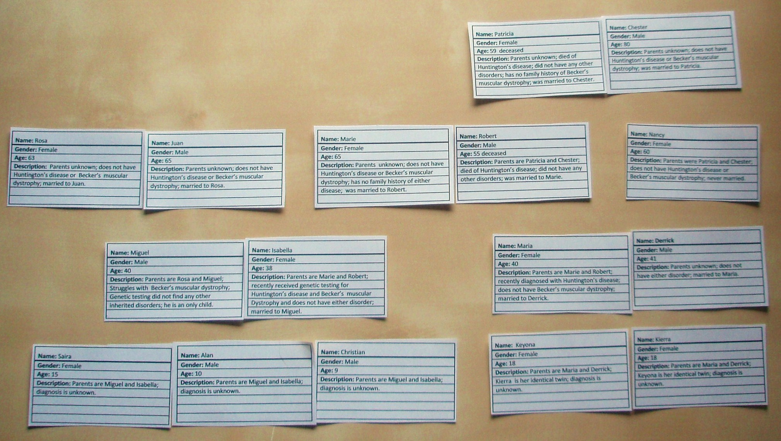
Photograph of Family Tree Sorting Activity
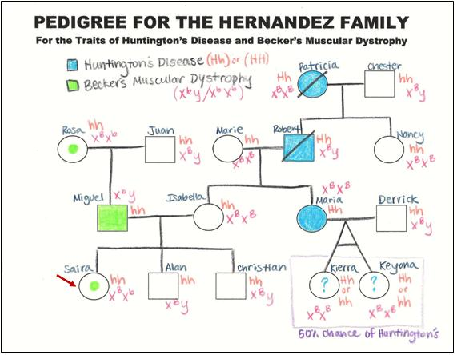
Sample Student Work: Pedigree and Family History Analysis Activity
TEACHER KEY TO ANALYSIS AND CONCLUSION QUESTIONS

- Do Saira and her family have reason for concern? What is the probability that Saira, Alan, Christian, Keyona and Kierra will have either trait? Create Punnett squares with their parents’ genotypes to justify and support your answer. (10 points)
Saira and her family do have reason for concern because it is probable that these genetic disorders will continue to reoccur in their family over many generations. Saira does not have either trait, but is a carrier for Becker’s muscular dystrophy and could pass this gene on to her children. Any son that she has will develop this disorder and there is a fifty percent chance that any daughter will be a carrier for the disorder. Alan and Christian will not develop either disorder and are not carriers. Keyona and Kierra have a fifty percent chance of developing Huntington’s disease and may want to get genetic testing.
 | h | h
h | hh | hh
h | hh | hh

Miguel and Isabella’s cross for Huntington’s disease. There is a no chance of Saira, Alan, and Christian developing Huntington’s disease.

 | X^{b} | Y
X^{B} | X^{B} X^{b} | X^{B} Y
X^{B} | X^{B} X^{b} | X^{B} Y

Miguel and Isabella’s cross for Becker’s muscular dystrophy. Saira has a hundred percent chance of being a carrier of this disorder, but no chance of developing it. Alan and Christian have no chance of developing the disorder, nor are the carriers, since males cannot be carriers of X-linked traits.
 | h | h
H | Hh | Hh
h | hh | hh

Maria and Derrick’s cross for Huntington’s disease. There is a fifty percent chance of Keyona and Kierra developing Huntington’s disease.

 | X^{B} | Y
X^{B} | X^{B} X^{B} | X^{B} Y
X^{B} | X^{B} X^{B} | X^{B} Y

Maria and Derrick’s cross for Becker’s muscular dystrophy. There is no chance of Keyona and Kierra developing Becker’s muscular dystrophy.

- Can individuals be carriers for both traits? Why or why not? (5 points)
Individuals cannot be carriers for Huntington’s diseases because it is an autosomal dominant trait and therefore they either have the trait or they don’t. If it was an autosomal recessive trait, then there could be carriers. Individual can be carriers for Becker’s muscular dystrophy because it is an X-linked recessive trait. Females can be carriers of this trait, while males cannot. Males only have one X chromosome and therefore will either have the trait or not. Females have two X chromosomes and therefore could be heterozygous for the trait, making them carriers.

- Were any of the individuals in the Hernandez family carriers for a trait? How did you deduce this? (5 points)
Both Rosa and Saira are carriers for Becker’s muscular dystrophy. Rosa’s son, Miguel, has the trait and since he only receives an X chromosome from his mother, she would have had to give him the allele. Saira’s father, Miguel, has the trait and would have contributed his X chromosome, which contains the allele for the trait. Since her mother, Isabella, has no family history of Becker’s muscular dystrophy, she would be a carrier.
Name: ___________________________________ Period: __________ Date: ______________

Pedigree and Family History Analysis Activity

Introduction:
Saira Hernandez is learning about genetics in her Biology class and recently became concerned about her own health because she learned that many disorders and diseases can run in families. Her father suffers from Becker’s muscular dystrophy (BMD), a disorder in which muscles grow progressively weaker. Saira learned in Biology class that BMD is a sex-linked trait inherited by a recessive gene on the X chromosome. She is also worried because her aunt Maria was just diagnosed with Huntington’s disease (HD), a progressive neurodegenerative disorder, which is inherited by an autosomal dominant gene. After learning about how to construct a pedigree in class, Saira collected all of her family health history information onto index cards. Today, you will be working as a geneticist to determine the phenotypes and genotypes of her family by constructing a pedigree.

Problem: What is the probability that Saira and her family with have either Becker’s muscular dystrophy or Huntington’s disease?

Procedure:
- Obtain Saira Hernandez’s family health history index cards.
- Sort the index cards into familiar relationships, constructing a “family tree”.
- Use the information supplied on the index cards to create a pedigree for the Hernandez family:
  - Neatly diagram the Hernandez family using proper pedigree symbols, refer to handout on symbols (indicating where your proband, genetic subjects, are in red - 2 points).
To complete your diagram you can:
- draw it
- use a software program like Microsoft PowerPoint or Paint
- use internet resources - example: Family History Online Pedigree Tool https://familyhistory.hhs.gov/
  - On the top of your page, title your pedigree “"PEDIGREE OF THE (last name) FAMILY, FOR THE TRAITS OF (2 traits analyzed)" (1 point).
  - Use two different colors to differentiate between BMD and HD. MAKE SURE YOU INCLUDE A LEGEND! (Neatness and legend – 10 points)
  - Place your name, class period, and date on the back of your paper (1 point).
  - Use standard 8.5 x 11 white, unlined paper.
All 16 individuals graded: ½ point for correct symbol, ½ point for correct connection, ½ point for the identifying of each trait (only recognized if properly colored) and 6 points for labeling the individuals by first name (30 points).
- Use the information on your pedigree to determine if any family members are carriers of either trait and indicate this on your pedigree using the correct symbols. (It may not be possible for both traits to be carriers. That is something you will have to figure out!)
- Genetic information is not currently available for Saira, her brothers, or cousins. Deduce the probability of that they will have either genetic disorder using the available genetic information on your pedigree and indicate your findings on your pedigree. If you cannot determine a trait with 100% probability, then place a “?” for each person, using the appropriate color for the trait.
- Designate the genotype of each individual on the pedigree for both traits. Some individuals may have more than one possible genotype for a trait; use the family health history to guide you. Assign letters appropriately for each allele and include them in your legend. (16 points)
- Answer the “Analysis and Conclusion” questions in complete sentences, demonstrating your analysis and understanding of your pedigree. (20 points)

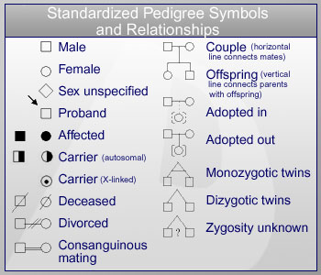
If you need a symbol for something not shown in the reference box, check the following websites:

- http://www.usd.edu/med/som/genetics/curriculum/2BHIST2.htm

- http://mchneighborhood.ichp.edu/pacnorgg/GNW/GeneticFamilyHx.html

- http://www.pubmedcentral.nih.gov/picrender.fcgi?artid=2444420&blobtype=pdf

ANALYSIS AND CONSLUSION:

- Do Saira and her family have reason for concern? What is the probability that Saira, Alan, Christian, Keyona, and Kierra will have either trait? Create Punnett squares with their parents’ genotypes to justify and support your answer. (10 points)

- Can individuals be carriers for both traits? Why or why not? (5 points)

- Were any of the individuals in the Hernandez family carriers for a trait? How did you deduce this? (5 points)

Additional resources
Websites frequently change, so some of these resources may no longer be available. Use a search engine and related key words to locate new websites.

- http://www.cdc.gov/genomics/activities/famhx.htm
The Center for Disease Control: Evaluating Family History for Preventive Medicine and Public Health
- www.kumc.edu/gec/resource.html
Genetics education materials
- https://familyhistory.hhs.gov/fhh-web/home.action
My Family Health Portrait is the Web-based tool from NHGRI and the U.S. Surgeon General's Family History Initiative that helps you create your own family health history.
- http://www.geneticalliance.org/ws_display.asp?filter=fhh
The Genetic Alliance is a wonderful global resource. In particular, there is a booklet that gives detailed information on how to gather a family health history.
- http://genealogy.about.com/library/nrelationshipchart.htm
This discusses the degree of relatedness for relatives
- http://www.biology.biolabsoftware.com/pdf/PedigreeLab.pdf
Pedigree Practice Worksheet
- http://www.ornl.gov/sci/techresources/Human_Genome/education/education.shtml
This website of the government-funded Human Genome Project has links about genomics, the history of the project, and more.

